PROJECT DEVELOPMENT PLAN

Version 1.0

Revision History

Date | Version | Descriptions | Author(s) | Reviewers

Table of Contents

1. INTRODUCTION 4
1.1 Purpose of this document 4
1.2 Content of this document 4
1.3 Definitions, Acronyms and Abbreviations 4
2. PROJECT OVERVIEW 5
2.1 Project Purpose, Scope, and Objectives 5
2.2 Assumptions 5
2.3 Project Deliverables 5
3. SCHEDULE AND MILESTONES 6
3.1 Delivery Plan 8
4. PROJECT ORGANIZATION 9
4.1 Staffing - Roles and Responsibilities 9
4.2 Organization Structure 9
5. PROJECT MANAGEMENT 10
5.1 Project Monitoring and Control 10
5.2 Project Communication 10
5.3 Training 11
6. HARDWARE & SOFTWARE 11
6.1 Hardware 11
6.2 Software 11
7. SUPPORTING PROCESS PLANS 11

INTRODUCTION

Purpose of this document

This document is the Project Development Plan for the project.
TMA's project leader and the customer project manager will use this to track the project progress.
The project team members will refer to this document to understand what needs to be done, and the scheduled delivery dates.

Content of this document
- Project Overview
- Project Organization
- Schedule and milestones
- Managerial process
- Technical process
- Supporting process plans

Definitions, Acronyms and Abbreviations

PROJECT OVERVIEW

Project Purpose, Scope, and Objectives
The purpose of the project is to outsource development of 4 components

The scope of the project includes the following activities:
No. | Sub-project | Includes | Excludes
1
2
3
4

Assumptions
This plan is based on following assumptions:
- Throughout the project, the customer will provide at least one technical staff to work as interface with TMA project team to participate in the requirement analysis, testing, and knowledge transfer and address any involved issues.
- All required software, source code and documents would be provided on time.

Project Deliverables

NO. | DELIVERABLES | DESCRIPTIONS
1
2
3
4

SCHEDULE AND MILESTONES

Task Name | Duration | Start | Finish | Task Description
Analysis and Design | 16 | Mon 7/1/02 | Fri 7/26/02
System Analysis | 4 | Mon 7/1/02 | Fri 7/5/02 | Analyze code
Architecture redesign | 12 | Mon 7/8/02 | Fri 7/26/02 | Re-design the system on Windows platform (high-level)
Design review | 0 | Mon 7/22/02 | Mon 7/22/02
Test Plan and Test Cases | 4 | Mon 7/22/02 | Fri 7/26/02 | Extend the test cases for Solaris and add new test cases for System and Performance testing
Porting | 24 | Mon 7/29/02 | Fri 9/6/02
iCal component | 8 | Mon 7/29/02 | Fri 8/9/02 | Includes analysis, detailed design, coding and unit test
Command Interface, Configuration, Logging | 14 | Mon 8/12/02 | Tue 9/3/02 | Includes analysis, detailed design, coding and unit test
Notification Daemon | 4 | Mon 7/29/02 | Fri 8/2/02 | Includes analysis, detailed design, coding and unit test
Command Handler | 8 | Mon 8/5/02 | Fri 8/16/02 | Includes analysis, detailed design, coding and unit test
Application components | 24 | Mon 7/29/02 | Fri 9/6/02 | Includes analysis, detailed design, coding and unit test
Store Manager and BDB | 10 | Mon 8/19/02 | Tue 9/3/02 | Includes analysis, detailed design, coding and unit test
Integration and Testing | 28 | Mon 8/12/02 | Fri 9/27/02
Integration | 20 | Mon 8/12/02 | Fri 9/13/02
Integration Test | 20 | Mon 8/12/02 | Fri 9/13/02
System Test | 8 | Mon 9/16/02 | Fri 9/27/02
Installer | 22 | Thu 8/22/02 | Fri 9/27/02
Design | 4 | Thu 8/22/02 | Tue 8/27/02 | Includes design, internal design review and rework
Design review | 0 | Tue 8/27/02 | Tue 8/27/02
Implementation | 12 | Thu 8/29/02 | Tue 9/17/02 | Includes Coding, Code Review, Unit Test and Rework.
Testing and Bug Fixing | 4 | Thu 9/19/02 | Tue 9/24/02
Documentation | 2 | Thu 9/26/02 | Fri 9/27/02 | Installation's Guide
Document and Packaging | 4 | Mon 9/30/02 | Fri 10/4/02
Documentation | 4 | Mon 9/30/02 | Fri 10/4/02 | Developer's Guide, Administration Guide
Packaging | 2 | Thu 10/3/02 | Fri 10/4/02 | to CD
Delivery | 0 | Fri 10/4/02 | Fri 10/4/02

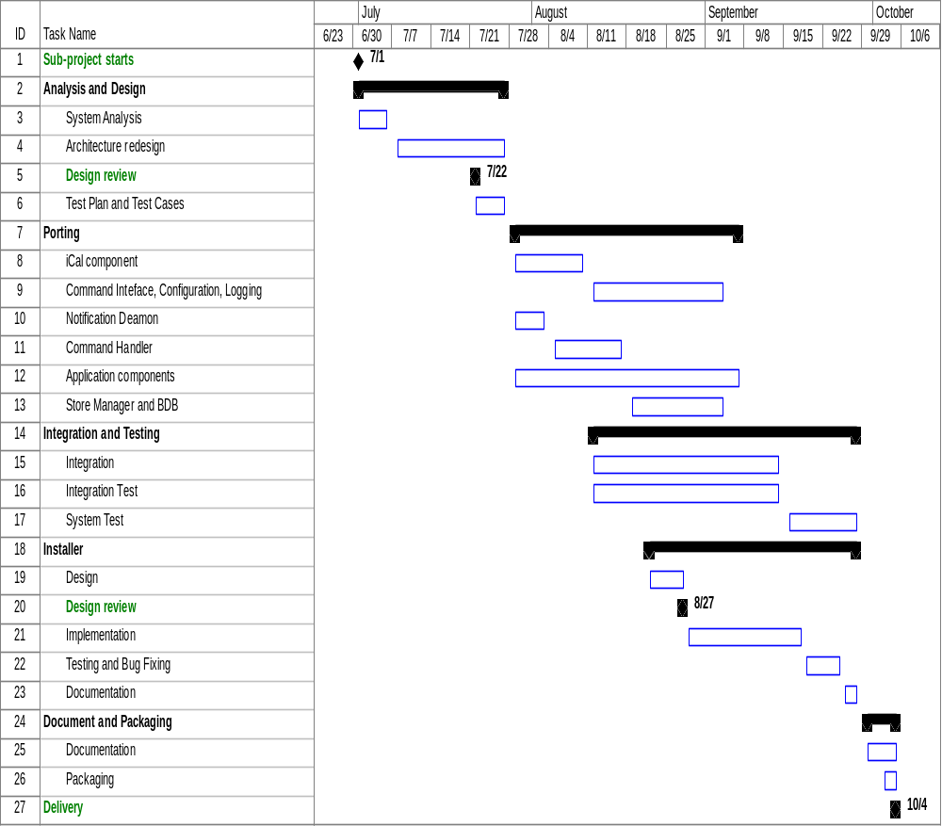

Delivery Plan

NO. | DELIVERABLES | WEEK # | DATE
1
2
3
4
5
6
7
8

All deliverables will be sent to the customer via FTP

PROJECT ORGANIZATION

Staffing - Roles and Responsibilities

No. | Name | Skills | Responsibilities

Organization Structure
Technical Director
Project manager
TEAM 2
Member
Member
Member
TEAM 1
Member

TEAM 3
Member

PHASE 1

PROJECT MANAGEMENT

Project Monitoring and Control

- The progress of work will be tracked and checked against the plan each week by the project leader.
- Internal review meetings will be held at the end of each week and at the completion of each milestone. At the internal review meetings, the team will report the status of each task, review the achievement, raise any issues and decide on actions to resolve any problems or issues. The project manager will adjust the project plan as necessary.
- External review meetings will be held at the completion of each milestone by conference calls to the Customer interface. The checklist of deliverables will be verified and updated.
- Main tasks will be divided in to several smaller sub-tasks and small milestones to keep track true progress.

Project Communication

- WEEKLY REPORT
    - Time: Every Monday
    - Reporter: Project manager
    - Content: project status & progress, issues/problems

- WEEKLY CONFERENCE CALL
    - Time:
    - Attendees: The Customer Project Manager and TMA development team/project leader.
    - Purpose: review project status and address outstanding issues/problems.

- INTERNAL WEEKLY MEETING
    - Time: On every Friday afternoon
    - Attendees: TMA development team
    - Purpose: review project status/progress and address outstanding issues/problems.

Training

Following are list of internal training sessions and seminars:

No. | Name | Week # | Status | Instructors/Presenters
1
2
3
4
5

HARDWARE & SOFTWARE

Hardware

No. | Name | Purpose | Configuration
1
2

Software

No. | Type | Name
1
2
3
4

SUPPORTING PROCESS PLANS
Following are list of supporting plans that described in separated documents.
- Requirement Management
- Risk Management Plan
- Configuration Management Plan
- Quality Assurance Plan
- Test Plan

